Tabloid

A tabloid is a newspaper, especially one that's smaller than a traditional daily paper and focuses on sensational news items.

IF you are lucky, you will read juicy tabloid headlines as you pass through news corner.

A tabloid is more likely to print celebrity gossip or crime stories with large photographs than news about international issues or the economy, especially on the front page. Tabloids aren't taken entirely seriously as journalism, although they are very popular and tend to sell well. The word *tabloid* originally meant "small tablet of medicine" in the 1880's. By 1900, it also meant "a compressed form of anything," including journalism.



Plebeian

In Roman times, the lower class of people was the plebeian class. Today, if something is *plebeian*, it is of the common people.

She loves adventurous life and that’s why, rejected him because of his plebeian taste about life.

When you hear the word *plebeian* used to describe a form of art or taste, it means that while something is liked by a lot of people, it may not be of the highest quality or taste. Both soap operas and reality television shows have been described as plebeian forms of entertainment. A member of the plebeian class is known as a pleb, which is pronounced "pleeb."

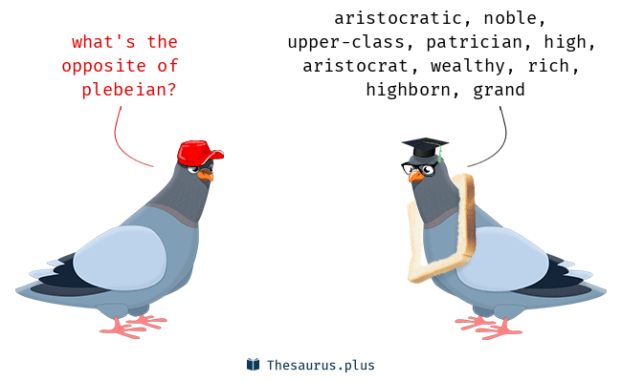

Manifold

Manifold is a smarty-pants way to say "varied," "many," or "multiple." There are many good ansay the benefits of learning new words are *manifold*.

*Manifold* sounds like "many fold," which is what it is — something with many features, like a wallet with lots of folds so stuffed with junk that makes you sit funny when it's in your back pocket. As an adjective, *manifold* loves to appear in books, like Mrs. Gryce in Edith Wharton's "The House of Mirth," whose "domestic duties were manifold." As a noun, a *manifold* is a pipe branching into many openings, often found in car engines.



Fig : Manifold inlets of pipes.

Hone

The verb hone means to sharpen skills. When you practice shooting baskets every day after school, you are *honing* your skills as a basketball player.

*Hone*, the verb, literally means to sharpen with a hone, a whetstone used to sharpen cutting tools. Use *hone* to describe someone working hard, perfecting or sharpening skills, as in "She is *honing* her skills as an actress by working in community theater." *Hone*, which rhymes with phone, is from the Old English word, *han*, meaning "stone, rock."

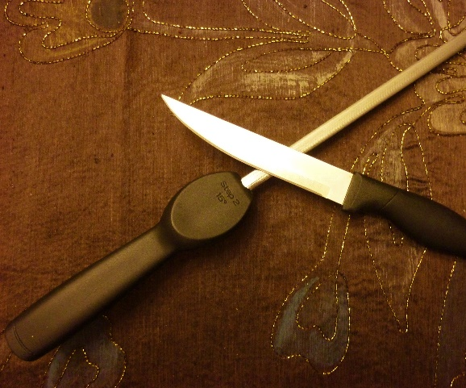

Impresario

An impresario is a promoter: someone who books, promotes, and organizes shows such as concerts.

Impresario comes from an Italian word for a businessperson, and in English it especially refers to someone in the promotion business. In the music business, Bill Graham was a famous impresario who arranged concerts for huge bands such as The Rolling Stones and Pink Floyd. An impresario signs a band — or other entertainment — and makes a deal with the venue. Impresarios then arrange advertising and promotion to alert fans and arrange for tickets to be sold. Impresarios make shows happen.

e.g.

Some impresarios are exploring ways to mitigate the impact of business closures in the age of coronavirus

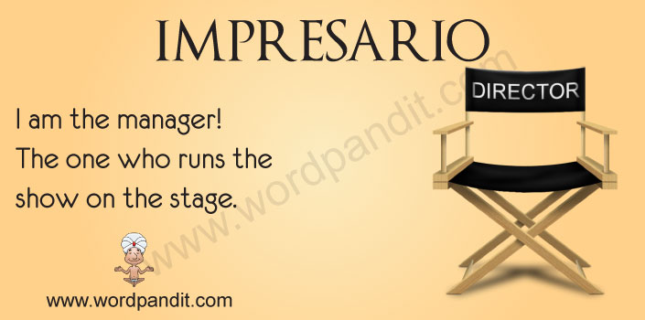

Zibaldone

A zibaldone is an Italian vernacular commonplace book. The word means "a heap of things" or "miscellany" in Italian.

The earliest such books were kept by Venetian merchants in the fourteenth century, taking the form of a small or medium-format paper codex

 